 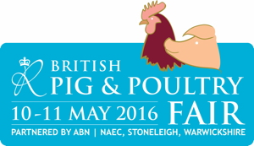

**PIG WORLD NEW PRODUCT AWARD**

**The 2016 Pig World New Product Award will be presented to the entry chosen by a judging panel as the best new product or service for the British pig industry exhibited at the British Pig & Poultry Fair on May 10/11. All entrants must be available for judging on the afternoon of May 10.**

|  |  |  |
| --- | --- | --- |
| **Name of product/service:** |  | |
| **Date launched in UK:** |  | |
| **Brief description of product/service:** |  | |
| **Cost of product/service:** |  | |
| **Product manufacturer or**  **service provider:** |  | |
| **UK distributor/provider**  **(if different):** |  | |
| **Address:** |  | |
| **Contact name  (at showground):** |  | |
| **Contact number  (at showground):** |  | |
| **Contact email:** |  | |
| OFFICE USE: | REC: | SEQ: |

Please email your completed form to: [graeme@lewisbusinessmedia.co.uk](mailto:graeme@lewisbusinessmedia.co.uk)

before 17:00 on May 4, 2016.